

综合实践项目中期检查报告
Mid-term Report of Practical Project

课题名称Topic：
Machine Vision-based Intelligent Recognition of Building Air Conditioning Interface
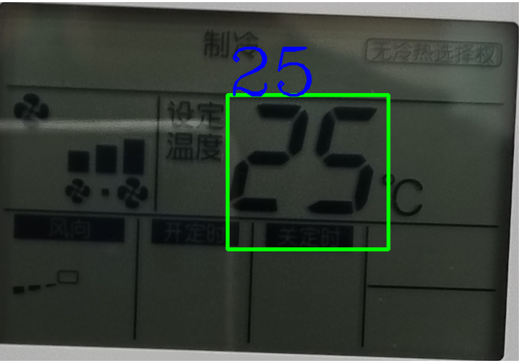
Figure 1: Illustration of our project’s first result
教师姓名Supervisor：Helin Gong
学生姓名Student：Babic Marko学号Student ID：J12426099007
专业名称Major：Computer Science - Information Engineer
学院(系)：巴黎卓越工程师学院SPEIT
综合实践项目课题的基本内容与要求：
Main research content and requirements of your project:
Main research content

The purpose of this project is to establish a model capable of reading the digits from an air-conditioner interface, from a picture.
Requirements and tools used

We decided to use python for his accessibility and for the reason that is a programming language easier to pick up.

We used Pycharm (developed by JetBrains) as our python Integrated Development Environment(IDE) with a python version 3.12.

Moreover, we needed different libraries in order to achieve our project at this point:
- cv2: An open-source computer vision library that provides a wide range of image and video processing functions.
- Numpy: A fundamental package for scientific computing with Python, providing support for arrays, matrices, and a variety of mathematical functions.
- Matplotlib: A plotting library used for creating static, animated, and interactive visualizations in Python.
- Easyocr: A simple, easy-to-use OCR (Optical Character Recognition) library that can recognize text from images with high accuracy with many parameters.

综合实践项目进度安排Researching plan：
No. | 各阶段内容 Progress | 时间安排Period | 备注Notes
1
2
3
4
5 | Find a supervisor and start of the project | 10th – 12th October
6 | Taking 200 hundreds of photos in SJTU. | 13th – 19th October
7 | Testing different python libraries | 20th – 27th October
8 | Establishing a first model | 28th October– 4th November
9 | Testing and upgrading the first model | 4th– 14th November
10 |   New version capable of reading at least 7 images. Finishing the midterm report. | 15th– 21th November
学生签名Student signature：

日期Date(YYYY-MM-DD)：
指导教师意见Comments from supervisor：

指导教师签名Supervisor signature：
日期Date(YYYY-MM-DD)：
学院（系）意见Comments from institute：

院长（系主任）签名Dean signature：
日期Date(YYYY-MM-DD)：

